

SFT 110

Assignment 3
Group-based
Mini-project

Name | Student ID | Comments

Assignment 3 (15%) – Turnitin Submission
Deadline: Thursday 17 December

In your groups, create an infographic poster on the importance of soft skills in the workplace (examples of infographic posters are included on the following page). The poster should be one page long, and should touch on at least three of the following areas:

- Team work
- Leadership
- Communication skills
- Time management
- Decision making
- Stress management
- Interpersonal skills

*You will present your poster to the class for Assignment 4 – Group Presentations.

The following readings on soft skills may help:

https://www.apa.org/ed/precollege/psn/2017/09/soft-skills

https://www.psichi.org/page/053EyeSpring01dApple?&hhsearchterms=appleby#.X4_U29UzaUk

When creating your infographic poster, your group should do the following:

Focus on a single, big message
It`s ideal to focus on a single, coherent, big message that the whole infographic aims at conveying through metaphors, visuals etc.
Blending visuals and colors with text
Using eye-catching colors and visuals without losing the richness of reading materials. Try to choose some primary colors and visuals to enrich the texture and design.
Think of a strategy for using the space
Aligning your elements properly depends on the usage of space; you should decide on which information to use that matches to best background of your choice. The reader should be guided throughout the steps until they get to the final destination point you want them to reach at.
Selecting the right fonts
Since you are not going to use too much text; you may come up with three main fonts for title/header, main body and a third to enrich the texture in general.
Design an eye-catching sketch
You need to think of a storyline that flows from one point to another by attracting the reader with an-eye catching layout.

Examples of Infographic Posters

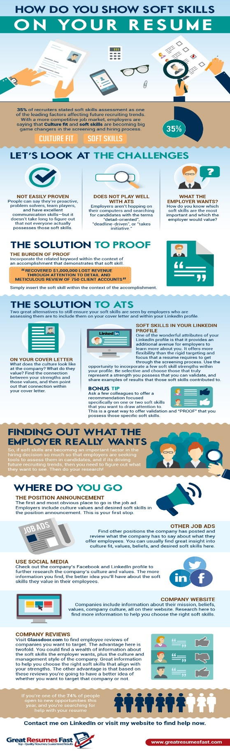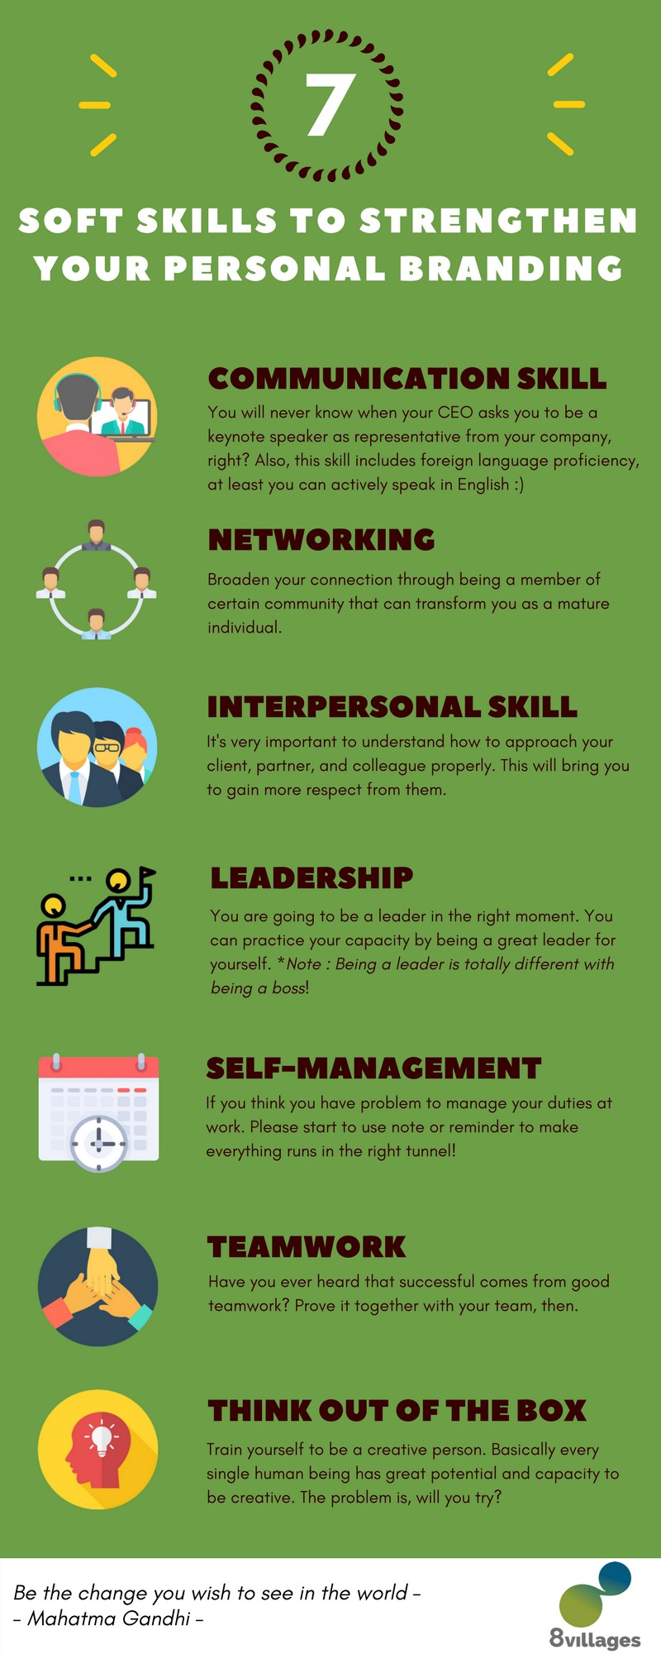

Grading Rubric

Infographic Poster(15%)
GROUP:_____________________________ | SECTION: ______ | TOPIC:________________________________
Criteria | Unsatisfactory | Poor | Satisfactory | Average | Good | Very Good
Focus on a single, big message | 0 | 1 | 2 | 3 | 4 | 5
Blending visuals and colours with text | 0 | 1 | 2 | 3 | 4 | 5
Selecting the right fonts | 0 | 1 | 2 | 3 | 4 | 5
Think of a strategy for using the space | 0 | 1 | 2 | 3 | 4 | 5
Design an eye-catching sketch | 0 | 1 | 2 | 3 | 4 | 5
TOTAL POINTS __________%
NOTES

